EXPERIMENT : 04

NAME : KISHORE.K ROLL NO : 240701267

Experiment: Design of Book Haven Mobile Application Interface

1. Aim
To design a user-friendly mobile interface for an online bookstore application called Book Haven, allowing users to login, view account details, check cart items, and track order history.

2. Objective
- To create a simple and attractive user interface.
- To allow users to securely login to the application.
- To display important user information like total spending, cart items, and order history.
- To provide easy navigation between application pages.

3. Tools Used
- UI Design Tool (such as Figma)
- Mobile Interface Design Principles
- Basic UI Components (Icons, Buttons, Input Fields)

4. Description of Interface
4.1 Login Page
The login page is the first screen of the application.
Features:
- Application title Book Haven displayed at the top.
- User icon to represent the account.
- Email input field for entering the user's email address.
- Password input field for entering the password securely.
- Login button to access the application.
- Forgot Password option to reset the password.
- Create Account option for new users to register.
Design Elements:
- Background image of a library/bookshelf to represent books.
- Dark theme with warm colors to create a reading atmosphere.
- Rounded input boxes for modern design.
Purpose:
- Allows secure user authentication before accessing the system.

4.2 Dashboard Page
The dashboard page appears after successful login.
Features:
- Displays user profile name (Alex M.) at the top.
- Logout option to exit the application.
- Information cards showing:
  - Total Spent – shows total money spent on books.
  - Cart Items – number of books currently in cart.
  - Order History – allows users to view previous purchases.
Additional Features:
- View Details button to see order information.
- Bottom navigation bar with:
  - Home
  - Cart
  - Profile
Design Elements:
- Card-style layout for information display.
- Transparent cards with soft borders.
- Consistent color theme matching the login page.
Purpose:
- Provides quick access to important account information.

5. Advantages
- Simple and clean interface.
- Easy navigation for users.
- Attractive visual design suitable for a book store.
- Important information displayed clearly.

6. Result
The Book Haven mobile interface was successfully designed with a login page and dashboard page, providing users with a simple, visually appealing, and easy-to-use bookstore application interface.

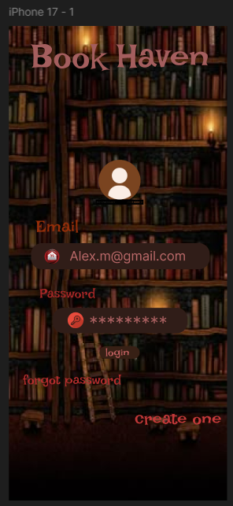

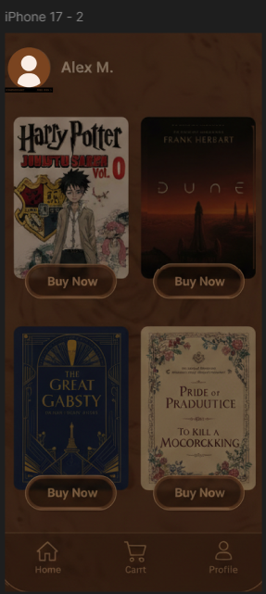

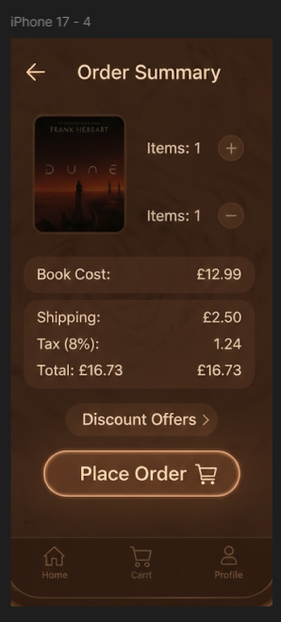



LINK:
https://www.figma.com/design/WyhOHqJscsRA3oJxRhTzZB/Untitled?node-id=0-1&t=jBxvzutIwtuj9fgG-1

